Chapter 8 Practice Exercises
Instructions: For all confidence interval exercises, begin your solution by checking the appropriate assumptions. Then, interpret the confidence interval. The inclusion of a correct interpretation is always implied in the instructions.
Exercise 1
An investigator wishes to estimate the true mean tar content in a certain brand of cigarettes. The tar content was measured for each cigarette in a random sample of 41 cigarettes. The mean is 14.4 milligrams with a standard deviation of 0.4 milligrams.
- Estimate the parameter with a 95% confidence interval.
- What is the point estimate of the parameter?
- What is the standard deviation of the point estimate?
- What is the critical value?
- What is the margin of error?
- It is desired to reduce the bound on the error of estimation to 0.1 milligram by conducting another study using a larger sample of cigarettes. How large of a sample is needed to estimate the true mean tar content to within 0.1 milligram with 95% level of confidence?

Exercise 2
A researcher wishes to estimate the true proportion of people with blood type B. From a random sample of 1,000 people, 120 were of blood type B.
- Use the data to construct a 98% confidence interval for the true proportion of people with blood type B.
- Specify the margin the error.
- How large of a sample is needed to estimate the proportion to within 0.02 with a 98% confidence level? Use the estimate of p from the existing sample.

Exercise 3
A pharmaceutical company is running preliminary trials for a new painkiller. A volunteer sample of 16 subjects with migraine headaches is given the new drug. The time required for the drug to take effect is recorded for each subject. The mean and standard deviation of the data is 15.3 minutes and 3.2 minutes, respectively.
- Construct a 95% confidence interval for the true mean time required for the drug to take effect. Address any concerns you have about the conclusion.
- Specify the margin of error.
- The investigator wishes to increase the sample so as to estimate the true mean to within ½ minute. How large of a sample is necessary to estimate the true mean to within ½ minute with a 95% level of confidence?

Exercise 4
A nutritionist wants to estimate the true proportion of American adults that eat breakfast every day. In a random sample of 400 American adults, 220 reported eating breakfast every day.
- Use the data to construct a 95% confidence interval for the true proportion of American adults that eat breakfast every day.
- Specify the margin of error?
- It is desired to reduce the bound on the error to within ± 0.03 with a 95% level of confidence. Find the minimum sample size required to accomplish this goal. Assume no knowledge of an estimate for p.

Exercise 5
A campus poll was conducted to determine the proportion of students that are satisfied with the quality of the university’s dining service. From a random sample of 100 students, the proportion was estimated to within ± 0.05. How large of a sample is necessary to estimate the proportion to within ± 0.025 with the same level of confidence?
Exercise 6
A seed company claims that 85% of the seeds of a certain variety of tomato will germinate if sown under normal growing conditions. A government inspector is interested in whether or not the actual proportion of seeds that germinate is living up to the company’s claim. The inspector randomly selects a sample of 150 seeds from a large shipment and tests the sample for percentage germination. He observed that 111 of the 150 seeds actually germinated.
- Compute a 95% confidence interval for the true proportion of all seeds of this variety that will actually germinate.
- Which number is the point estimate for the population proportion?
- Which number is the standard deviation of your point estimate?
- Which number is the critical value?
- Which number is the margin of error?
- Does this confidence interval contain the value of 0.85 (the proportion that is claimed by the company)? What do you infer?

Some Theory Problems
Exercise 7
For a large sample size n, what is the distribution of 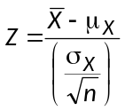 ? What must we assume about the distribution of the sampled population (X)?
Exercise 8
If the sample size is small, what assumption must be made so that has a standard normal distribution?
Exercise 9
If the population standard deviation σ_{X} is replaced by the sample standard deviation s_{X}, what is the distribution of 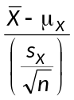? What must we assume about the distribution of the sampled population (X)?
Exercise 10
As the sample size becomes larger and larger, the distribution of 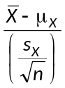gets close and closer to a ______________ distribution. Comment about the assumption of the distribution of the parent population (X)?
Exercise 11
Who “invented” the Student’s t-distribution? Where did he work?
Exercise 12
- Regarding a confidence interval from a fixed sample size and fixed standard deviation, as the confidence level increases, the margin of error ___________________________.
- Regarding a confidence interval from a fixed confidence level and fixed standard deviation, as the sample size increases, the margin of error _______________________.
- Regarding a confidence interval from a fixed sample size and fixed confidence level, as the standard deviation increases, the margin of error ________________________________.
Exercise 13
The following pictures represent sampling distribution for two different estimates of the population mean. Samples were drawn from a population with a mean of 7.
a. Which distribution has a lower bias? Why?
b. Which distribution has a lower variability? Why?
A | 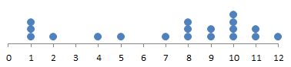
B | 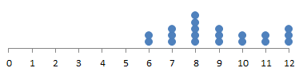

Exercise 14: Multiple Choice
In general, how does doubling the sample size change the margin of error?
A. Doubles the margin of error
B. Halves the margin of error
C. Multiplies the margin of error by 1.414
D. Divides the margin of error by 1.414
E. This question cannot be answered without knowing the sample size.

Exercise 15: Multiple Choice
A confidence interval estimate is determined from the body mass index of a simple random sample of size n students. All other quantities being equal, which of the following will result in a smaller margin of error?
I A smaller confidence level
II. A smaller sample standard deviation
III A smaller sample size
A. I and II
B. I and III
C. II and III
D. I, II, and III
E. None of the above gives the complete set of true responses.
Exercise 16: Multiple Choice
In a test for acid rain, a simple random sample of 51 water samples showed a mean pH level of 4.4 with a standard deviation of 0.35. Find a 90% confidence interval estimate for the mean pH level.
A. 4.4 ± 0.01
B. 4.4 ± 0.08
C. 4.4 ± 0.32
D. 4.4 ± 0.35
E. 4.4 ± 0.58
Exercise 17: Multiple Choice
What sample size should be chosen to find the mean number of absences per month for school children to within ±0.2 at a 95% confidence level if it is known that the standard deviation is 1.1?
A. 11
B. 29
C. 82
D. 96
E. 117

Exercise 18: Multiple Choice
Two confidence interval estimates from the sample are (16.4, 29.8) and (14.3, 31.9). What is the sample mean, and if one estimate is at the 95% level while the other is at the 99% level, which is which?
A. = 23.1; (16.4, 29.8) is the 95% confidence interval.
B. = 23.1; (14.3, 31.9) is the 95% confidence interval.
C. It is impossible to completely answer this question without knowing the sample size.
D. It is impossible to completely answer this question without knowing the sample standard deviation.
E. It is impossible to completely answer this question without knowing the sample size and the sample standard deviation.
Exercise 19: Multiple Choice
Under what conditions would it be meaningful to construct a confidence interval estimate when the data consist of the entire population?
A. If the population size is small (n < 30)
B. If the population size is large (n > 30)
C. If a higher level of confidence is desired
D. If the population is truly random
E. Never
Exercise 20: Multiple Choice
In order to decrease the margin of error by a factor of 3, the sample size must be
A. increased by a factor of 3
B. increased by a factor of 9
C. decreased by a factor of 3
D. decreased by a factor of 9
E. cannot tell from the given information.

Exercise 21: Multiple Choice
A behavioral psychologist is trying to determine the length of the average vacation stay at a resort. She finds that a random sample of 48 vacations can determine the average length to within a day at a 90% confidence level. If she wants to improve the margin of error to within a half a day, how many vacations need to be examined?
A. 24
B. 48
C. 96
D. 132
E. 192

Exercise 22: Multiple Choice
Which of the following is incorrect?
A. The length of a confidence interval will shrink if the standard deviation increases.
B. The length of a confidence interval will shrink if the standard deviation decreases.
C. The length of a confidence interval will shrink if the confidence level decreases.
D. The length of a confidence interval will shrink if the sample size increases.
E. The length of a confidence interval will shrink if the sample size increases and the confidence level decreases.
Exercise 23: Multiple Choice
The administration board for a large hospital system is interested in estimating the proportion of its employees that feel they are prepared for a major natural disaster. Thirty-seven randomly selected employees were asked, “Do you believe that this facility is prepared for a major natural disaster?” Of the 37 employees interviewed, 33 said yes, 2 said no, and 2 said they did not know. A z-confidence interval was constructed from these data to estimate the proportion of the hospital’s employees that believe they are prepared for a major natural disaster. Which statement is true?
- A z-confidence interval is a valid procedure because a sample size of more than 30 was used.
- A z-confidence interval is a valid procedure because the employees were asked the same question.
- A z-confidence interval is not a valid procedure because the quantity 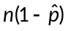 is too small.
D. A z-confidence interval is not a valid procedure because only one of the categories was chosen more than 30 times.
E. A z-confidence interval is not a valid procedure because “do not know” was included as a response category for the question.
Exercise 24: Multiple Choice
Which of the following is a condition for using a t-distribution for contructing a confidence interval for a population mean?
A. The mean of the population is known
B. The standard deviation of the population is known
C. The sample is not normally distributed
D. The population size is small
E. The sample size is large or the population is normally distributed
Exercise 25: Multiple Choice
A research group has taken a random sample from the population of sewer rats in New York City. Using the rats in this sample, they want to estimate the mean tail length of all New York City sewer rats. One half of the research group wants to construct a 95 percent confidence interval for the true mean tail length, the other half wants to construct a 99 percent confidence interval for the true mean tail length. How will these intervals differ?
A. The 95 percent confidence interval will be wider than the 99 percent confidence interval.
B. The 99 percent confidence interval will be wider than the 95 percent confidence interval.
C. The sample size will determine which interval is wider.
D. Whether the sample is biased or unbiased will determine which interval is wider.
E. The type of critical value, z or t, will determine which interval is wider.

Exercise 26: Multiple Choice
In January 2014, Gallup Poll published a survey of adult citizens in Russia showing their opinion of the Olympic Winter Games in Sochi. When asked whether the games would help promote sports development in Russia, 84 percent of the respondents said yes. The poll of 2000 adults, conducted in July and August of 2013, had a margin of error of 2.7 percent. Which of the following statements best describes what is meant by the 2.7percent margin of error?
A. Not all of the 2000 adults knew anything about the Olympics.
B. About 2.7 percent of the 2000 adults polled refused to answer.
C. About 2.7 percent of adults were expected to change their minds between the time of the poll and its publication in January 2014.
D. The difference between the sample percentage and the population percentage is likely to be less than 2.7 percent.
E. There is about a 2.7 percent chance that this survey captured the true proportion of Russian adult citizens who would answer yes to the question.
Exercise 27: Multiple Choice
A restaurant manager has the responsibility of verifying that the drink machine at his restaurant is filling the cups properly. The manager will randomly select a sample of filled cups each day and measure the volume of liquid in each cup. Past measurements have shown that the standard deviation of liquid dispensed by this machine is about 0.2 ounces. An estimate of the mean volume must be reported to within a margin of error of 0.1ounces with 98 percent confidence. What is the minimum sample size for the number of drinks the manager must select?
A. 2
B. 5
C. 16
D. 17
E. 22

Exercise 28: Multiple Choice
A biologist is studying the fire salamander in Southern Europe and is interested in estimating the mean length of adult female fire salamanders living in a particular river system. She has collected a random sample of 20 adult female fire salamanders. The actual population distribution of lengths is not known to be normal, but a graphical display of lengths from the biologist’s sample results indicates that the assumption of normality is not unreasonable. The salamander is newly discovered in the region and there is no previous record of variability for the population lengths. When estimating the population mean length for adult female fire salamanders in this region using this sample data, the biologist should use a t-confidence interval rather than a z-confidence interval because the biologist
A. the biologist is using data from a specific region only.
B. the biologist is using data, rather than theory to judge that the length is normal.
C. the biologist is using the sample mean length to estimate the population mean length.
D. the biologist is using the sample standard deviation as an estimate of the population standard deviation.
E. the biologist has a sample of only 20 salamanders, and a z-confidence interval should never be used with a sample size less than 30.

Exercise 29: Multiple Choice
Which of the following statements is (are) true about a t-distribution?
- A t-distribution has a larger variance than the standard normal distribution.
II. As the number of degrees of freedom increase, the t-distribution approaches a standard normal distribution.
III. A t-statistic of 3 (or greater) with 10 degrees of freedom is more likely than a t-statistic of 3 (or greater) with 12 degrees of freedom.
A. I only
B. II only
C. I and II only
D. II and III only
E. I, II,and III

Exercise 30: Real Important!
Twenty-four salmon were caught from Pick Creek and their weight was measured. A 95% confidence interval for the true mean weight was calculated to be (67.7 ounces, 83.9 ounces). Assume all conditions for a confidence interval have been met.
- Interpret the confidence interval.
- Interpret the confidence level.

Solutions to Chapter 8 Exercises
Exercise 1
We wish to estimate μ, the true mean tar content of this brand of cigarette, with a 95% CI.
Check the conditions:
- A random sample of cigarettes was selected. ✓
- Certainly, more than 410 cigarettes of this brand have been (and will be) manufactured. ✓
- The sample size is large (n = 41 > 30). ✓
Use a t-CI for a mean (σ is unknown). Use a t-distribution with 40 df.
- 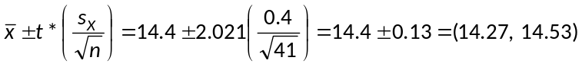
We are 95% confident that the true mean tar content of this brand of cigarette is between 14.27 mg and 14.53 mg.
- The point estimate of μ is 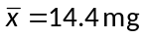.
- The standard deviation of is 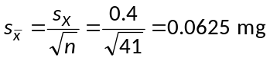.
- The critical value is t* = 2.021.
- The margin of error is 0.13 mg.
- 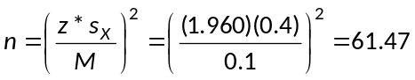.
A minimum of 62 cigarettes are needed to estimate the true mean tar content to within 0.1 mg of the true value with a 95% level of confidence.

Exercise 2
We wish to estimate p, the true proportion of people with blood type B, with a 95% CI.
Check the conditions:
- A random sample of people was selected. ✓
- We will need to assume there are more than 10,000 people in the population of interest. ✓
- Note that 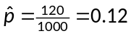. Check for large counts.
✓
Use a z-CI for a proportion. Use a z-distribution.
- .
We are 98% confident that the true proportion of people with blood type B is between 0.096 (9.6%) and 0.144 (14.4%).
- The margin of error is 0.024 (2.4%).
- Since we have a preliminary estimate of , we will use it in the sample size formula.
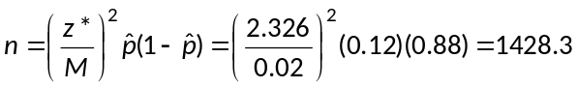
A minimum sample of 1429 people is needed to estimate the true proportion of people with blood type B to within 0.02 of the true proportion.

Exercise 3
We wish to estimate μ, the true time required for the drug to take effect, with a 95% CI.
Check the conditions:
- The sample is a volunteer sample and not a random sample. Proceed with caution!!!
- It is safe to assume that there are more than 160 people with migraine headaches. ✓
- The sample size is not large. Nor is there any mention of the time to relief being normally distribution. This condition is not met. Once again, we are to proceed with caution!!!
Use a t-CI for a mean (σ is unknown). Use a t-distribution with 15 df.
- 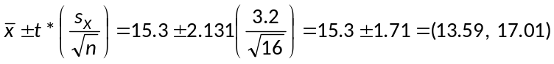.
We are 95% confident that the true mean time to relief is between 13.59 minutes and 17.01 minutes. But again, the results are subject to some scrutiny. The conditions for this inference have not been met.
- The margin of error is 1.71 minutes
- 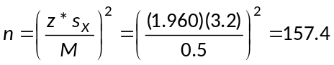.
A minimum random sample of 158 people is needed to estimate the true time to relief to within ½ minutes of the true value with a 95% level of confidence.

Exercise 4
We wish to estimate p, the true proportion of American adults that eat breakfast every day, with a 95% CI.
Check the conditions:
- A random sample of people was selected. ✓
- There are certainly more than 2200 American adults. ✓
- Note that 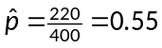. Check for large counts. ✓
Use a z-CI for a proportion. Use a z-distribution.
- .
We are 95% confident that the true proportion of Americans that eat breakfast every day is between 0.501 (50.1%) and 0.599 (59.9%).
- The margin of error is 0.049 (4.9%).
- We are told to make no assumptions about the proportion. So, use 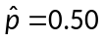in the sample size formula.
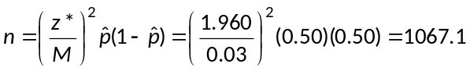
A minimum sample of 1068 American adults is needed to estimate the true proportion of American adults that eat breakfast every day to within 0.03 of the true proportion.

Exercise 5
Remember that the margin of error is inversely proportion to the square root of the sample size. In order to reduce the margin of error by a factor of 2 (from 0.05 to 0.025), the sample size must be increased by a factor of 4. Answer: A minimum sample of 400 students is needed.
You are advised to be familiar with this type of question! It is also addressed in the multiple choice section of this review.

Exercise 6
We wish to estimate p, the true proportion of seeds that germinate, with a 95% CI.
Check the conditions:
- A random sample of seeds was selected. ✓
- We will assume there are more than 1500 seeds. ✓
- Note that 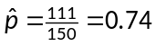. Check for large counts. ✓
Use a z-CI for a proportion. Use a z-distribution.
- .
We are 95% confident that the true proportion of seeds that germinate is between 0.670 (67.0%) and 0.810 (81.0%).
- The point estimate for p is .
- The standard deviation of is 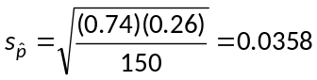
- The critical value is z* = 1.960.
- The margin of error is 0.070 (7.0%)
- We conclude that the true percentage of seeds that will germinate is somewhere between 67% and 81%. This range does NOT include the company’s claim of 85%. We infer that the company’s claim is too high. Our data do not support the company’s claim!

Exercise 7
Z has a standard normal distribution. No assumptions are needed about the distribution of the sampled population. Since the sample size is large, the Central Limit Theorem assures us that the distribution of is approximately normal regardless of the distribution of the sampled population.

Exercise 8
If the sample size is small, then we must assume that the sampled population has a normal distribution. This case uses Theorem 1 (and not the Central Limit Theorem).

Exercise 9
The statistic 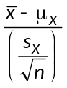 has a t-distribution with n – 1 degrees of freedom. We must assume that the sampled population has a normal distribution. However, this assumption becomes less and less important with larger values of n. This is why we check the condition of a normally distributed population OR a large sample size.
Exercise 10
As the sample size becomes larger and larger, the distribution of gets closer and closer to a standard normal distribution. The requirement of the sampled population having a normal distribution becomes less and less important.
Exercise 11
See page 8-12.
Exercise 12
- increases
- decreases
- increases
Exercise 13
- Distribution A has the lower bias. The center of this distribution is closer to 7 than is the center of distribution B.
- Distribution B has the lower variability. The spread of distribution B is much less than the spread of distribution A.
Multiple Choice
14. D 15. A
16. B 17. E
18. A 19. E
20. B 21. E
22. A 23. C
24. E 25. B
26. D 27. E
28. D 29 E
Exercise 30
- We are 95% confident that the true mean weight of all salmon in Pike Creek is between 67.7 ounces and 83.9 ounces.
- The method used to produce this interval will contain the true mean weight of all salmon in Pike Creek in 95% of all possible samples of size n = 24 from this population.

